**PERSONALIZED RENT PAYMENT FOLLOW UP SYSTEM**

**PROJECT REPORT.**

**Submitted in partial fulfilment of the requirements for the degree of**

**Bachelor of Science in Information science**

**By**

**ERASTUS MULA KIMATU – ISC/12/2016**

**Under the guidance of**

**Dr. James Abila,**

**Department of Information Science and Informatics,**

**RONGO UNIVERSITY.**

OCTOBER 2020

# DECLARATION

This project, as presented in this report, is my original work and has not been presented for any other University award.

**Name: Erastus Mula Kimatu**

Signature: _________________________________________

Date: ____________________________________________

This project has been submitted as part fulfillment of requirements for the Bachelor of Science in Computer Science of Rongo University with my approval as the University supervisor.

**Dr.James Abila**

Department of Informatics and Information Science

School of Information, Communication and Media studies, Rongo University

Signature: _________________________________________

Date: ____________________________________________

# ABSTRACT

We are stuck with technology when what we really want is just stuff that works. With the current paradigm shift in technological field, there is an urgent need to embrace and appreciate the power of technology. Housing sector remains vigilant to face the challenges of change by employing a new strategy that facilitates easy management of rent in the rental houses. Hence there is need to develop a rent collection system that can simplify work for the rental managers so that all their work can be efficient and effective.

To get information about how rent payment is currently being followed, I went to a number of rental house managers and from the information I gathered I realized all work of following up rent payment was done manually with a lot of paper work involved. Papers can easily get damaged or get lost leading to loss of data. It is also expensive to keep on buying files to store your payment records. A lot of files make a place look untidy and also consume a lot of space. Getting a certain file to check data from many files becomes a difficult task.

Considering those facts, I decided to develop a rent collection system that can solve all the problems experienced with the current system. The system was developed in such manner that it provides maximum user friendly interface.

For manager faced with management difficulties here is a perfect solution for you. The rent payment follow up system is made for you.

Table of contents.

DECLARATION ii

ABSTRACT iii

CHAPTER ONE. 4

Introduction. 4

1.1 Background of the study. 4

1.2 Statement of the problem. 5

1.3 Purpose. 6

1.4 Objectives. 6

1.4.1 General Objective. 6

1.4.2 Specific Objectives 6

1.5 Research Questions. 6

1.6 Justification. 6

1.7 Project scope. 7

1.8 Delimitation. 7

1.9 Limitation. 7

1.10 Significance. 7

CHAPTER TWO. 8

Literature review. 8

2.1 Introduction. 8

2.2 Rent payment records. 8

2.3 Follow up system. 9

2.4 Follow up system and rent payment records. 9

2.5 Research gap. 10

2.6 Theoretical framework. 11

2.7 Conceptual framework. 12

2.7.1 Follow up system. 12

2.7.2 Payments records. 12

CHAPTER THREE. 13

Methodology 13

3.0 Introduction 13

3.2 Research Design. 13

3.3 Study area. 13

3.4 Study population. 13

3.5 Research instrument and data collection procedure. 13

3.5.1 Questionnaire. 14

3.5.2 Interview 14

3.6 Sampling. 14

3.6.1 Sample size 15

3.6.2 Sampling procedure. 15

3.7 Reliability and validity. 15

3.8 Piloting. 15

3.9 Data analysis and techniques. 16

3.10 Ethical considerations. 16

CHAPTER FOUR 17

DATA ANALYSIS, PRESENTATION AND INTERPRETATION 17

4.1 Introduction. 17

4.2 Respondents return rate on the questionnaires. 17

4.3 Demographic information. 17

4.3.1 Gender. 18

4.3.2 Age of respondents. 18

4.4 Response on software requirements to develop the proposed system 20

4.5 Response on how the payment information is followed. 21

4.6 Response on whether the system will be convenient. 22

CHAPTER 5 25

5.1 SYSTEM DESIGN 25

5.1.1 UML Design: 25

5.1.2 Use Case: 25

5.2 IMPLEMENTATION: 29

5.2.1 DEVELOPMENT ENVIRONMENT 29

5.2.2 IMPLEMENTATION ARCHITECTURE 29

5.3 SYSTEM TESTING 29

5.3.1. Unit testing 29

5.3.2 Integration testing 30

5.4 System demos 30

5.5 USER MANUAL 33

5.6 SUMMARRY, RECOMMENDATION, CONCLUSION AND THE PROBLEMS ENCOUNTERED 33

5.6.1 SUMMARY 33

5.6.2 CONCLUSION 33

5.6.3 RECOMMENDATION 33

5.6.4 PROBLEM ENCOUNTERED 34

APPENDIX I. MAP OF THE AREA 36

APPENDIX II. Budget. 36

APPENDIX III. Tools and research instruments. 36

References 37

APPENDIX IV. GLOSSARY 37

**Table of Figures.**

Figure 1: Conceptual framework. 12

Figure 2: Use case diagram 25

Figure 3: Level 0 DFD 26

Figure 4: Level 1 DFD 27

Figure 5: System Flowchart 27

Figure 6: ER diagram. 28

Figure 7: implementation architecture. 29

Figure 8: Caretaker login page, Registration page and view of the tenants in database 31

Figure 9: Database showing tenants. 31

**List of Tables**

Table 1: Respondents return rate. 17

Table 2: Gender distribution of respondents. 18

Table 3: Age of the respondents. 18

Table 4: Type of the respondents. 19

Table 5: Software requirements of the proposed system. 20

Table 6: Follow up in rent payment. 21

Table 7: Convenience of rent payment follow up system. 22

Table 8: Time savings in rent payment follow up. 23

Table 9: Budget. 35

Table 10: Tools and instruments. 35

# CHAPTER ONE.

# Introduction.

Follow up for payment information has become important factor in modern housing and hence something needs to be done to enhance it. This chapter will provide a brief understanding about background of study, definition of the project problem statement, its purpose, objectives, scopes, project justification, significance, delimitation, limitation and operational definition of terms.

## 1.1 Background of the study.

Rent payment and follow up describes the activities or series of events of payment followed by a landlord for a tenant to be given access to the rooms. Follow up is also monitoring which involves the collection and analysis of information about an activity, undertaken while the activity is ongoing. This can only be possible after paying money. Tenants are the people who live in the rooms and who need to pay so as to get access to the rooms.

Follow up will be done by the landlord by monitoring the payments done by the tenants.

Housing has a central importance to quality of life with considerable economic, social, cultural and personal significance. Though a country’s national prosperity is usually measured in economic terms, increasing wealth is of diminished value unless all can share its benefits and if the growing wealth is not used to redress growing social deficiencies, one of which is housing.

Housing as a basic human right demands that urban dwellers should have access to a decent housing, defined as one that provides a foundation for rather than being a barrier to good physical and mental health, personal development and fulfillment of life objectives. (Nations, 1948)

Following up the rent payments is still a major problem in Kenya. Millions of people are living in sprawling slams and also in other informal settlement around Nairobi where the payment records can only be accessed in person on files. These records may end getting damaged or lost due to accidents or even theft. The end results comes out that some people have not paid the rent because the records are not there.

Globally, monitoring these payments is really a great challenge in the modern world. Developing rental houses comes with many advantages especially to the Landlords who are able to increase their profits through rent paid by the tenants.

Increased number of tenants and Landlords makes management difficult especially for the landlords who are losing huge sum of money through tenants who evade rent paying the rent in time and end up escaping with part of the rent due to unavailability of the payment information.

Currently, the landlord has to keep the records of payments in the books or files. Using this method is a risk because data security is not assured leading to data being recorded on books or papers which may easily get damaged leading to loss of data. Also there is no database to store information which can lead to potential of data loss or damage because data is stored on tangible files. Lack of these crucial requirements makes monitoring of the tenants payments very difficult hence some tenants may end up not paying rent.

The above statement gives a clear declaration as to why a research on monitoring system development need to be done and also follow up on the operations done during the rent collection are done currently.

The focus of this research project or otherwise this study is basically looking for means managing keeping track of the payments done by the landlord from the database.

 This system will be used to monitor the data of payments on the go. It is becoming an important tool for industries that want real-time information about their fleet, personnel or merchandise. The system enables the business to run smoothly and effectively.

## 1.2 Statement of the problem.

In rental houses, rent payment follow up should be done through means which can easily track those who do not pay the money before the end of the required time to avoid tenants evading payments and also claiming payments which they have not done. There should also be a database to refer to incase of any issue for easy retrieval.

Over the years landlords have had a problem in managing their customers and their payment records. This has become difficult because of issues like data growth of the tenants and untrustworthy caretakers.

Currently most caretakers use the manual system in recording of the customers’ data and issuing of receipts which may end up getting lost or manipulating payments. Using this method is a risk because data security is not assured because there is no database to store information which can lead to potential of data loss or damage because data is stored on tangible files. Therefore, it is necessary to develop an automated system with user defined rules that save clients information into database, get the payments records of the user and keep a record of all the activities done.

## 1.3 Purpose.

This study aimed at investigating on how follow up of the payments will be efficient. The system requirements were gathered using various data collection techniques. These techniques allowed us to collect information about the objectives of the study. The following methods were used to collect data; interview where landlords of different residential houses were randomly selected and interviewed since they were the ones familiar with the current manual system of payment follow up.

The aims of the study were to come up with a system that would ensure easy follow up of payments by designing a system to cater for such issues.

## 1.4 Objectives.

### 1.4.1 General Objective.

To develop a follow up system after rent payment for Rongo community that will enable the caretakers to store data in database and manage the payments records in a convenient way enabling them to know anyone who might evade payments in the houses or who does not pay in time.

### 1.4.2 Specific Objectives

To study and analyze the requirement specifications of the rent payment follow up system.

To save the time of landlords and caretakers in following up payments.

To design a convenient and flexible system.

To implement the system.

To test and validate the system.

## 1.5 Research Questions.

1. What were the requirement specifications of the follow up system?
2. How much time would the system save in following up the payments?
3. How would the system be convenient?
4. How would the system be implemented?
5. How would the system be tested and validated?

## 1.6 Justification.

This research is necessary because it will help make it easy to deal with any payment information and tracking after the agenda of housing is brought to existence which is among the Uhuru’s big four agendas of the Republic of Kenya. This is because the houses will be very many and a lot of data will need to be automated to enhance easy identification of the tenants’ payment status every interval that is given to pay. It will also reduce the workload of the governmental houses once built to enhance easy follow up of payments.

## 1.7 Project scope.

This research was carried out at the private hostels and rental houses within the Rongo community and its surrounding. In this research, payment collection and tracking system was developed which would be used to capture data and manage all payments to enhance security. It would also be used to get those who do not pay in time specified. The data to be used was collected from records that we shall get from the residential areas and the landlords. The tenants were not left out in finding the information required.

## 1.8 Delimitation.

This study only targeted the landlords and tenants who were within the area I had given. Initially this study confined itself to interviewing and questionnaires the landlords and the tenants within the rental houses on the research problem. This study also confined to the Rongo community residential areas in Kitere market.

## 1.9 Limitation.

Tenants and landlords views. It was not be easy to get views from all the tenants and the landlords and include them in the research since they had varied ideas. Others were not willing to give the views after interrogating them. I tried to overcome this challenge by selecting a sample of the people ready to give views willingly.

Vast distances was also a limit hence it was better to choose a small geographical area to cover such a research because this influenced time and even finance in the research activities.

This purposive sampling procedure decreased the generalizability of the findings hence it was not generalized to all areas of payments and rent collections.

## 1.10 Significance.

This research work will enhance the efficiency and effectiveness of rent payment and follow up of the payments done by the tenants.

This will improve the system and make it more technologically convenient for the landlords enabling them to follow up the rent payment easily without the need of caretakers in the rental houses.

# CHAPTER TWO.

# Literature review.

Literature review is a text written by someone to consider the critical points of current knowledge including substantive findings as well as theoretical and methodological contributions to a particular topic. Main goals are to situate the current study within the body of literature and to provide context for the particular reader. (Cooper, 1998) .

## 2.1 Introduction.

This part will cover different sections which are explained below.

One of them is the dependent variable which is the rent payment which will explain about the rent payment conceptually and even contextually. The other part is the independent variable which is the follow up system which will cover the definitions from different perspectives and where they have been used. Research gap will give details of the problem and the operational definition of it too. Theoretical framework will talk about the summary of theory or theories that support the dependent and independent variable from different perspectives. Conceptual framework will be showing grammatically how the dependent and independent variables are related.

## 2.2 Rent payment records.

This variable depended on other factors that are measured. These variables were expected to change as a result of an experimental manipulation of the independent variable or variables.

A rental was an item that was leased out for a particular extent of time (Rental Property, 2015). It was governed by either a verbal or written agreement. Some of the most common forms of rentals were homes, cars, and equipment. These rentals required some form of payment, known as rent, to be made either at the commencement of the rental period or during the scheduled rental period (duhaime, 2015).

For a home rental, the landlord hires an agent or manager to take care of the property on his behalf. A rental agency receives compensation to coordinate the dealings between potential tenants and landlords. Other landlords take it as their main job to manage the properties. In the latter scenario, the tenants will be interacting with the landlord mostly especially in rent payment. When a real estate agent or company is hired, they take it upon themselves to collect the rent and manage tenant demands.

Rent is normally paid monthly. This depends upon the agreement signed with the landlord or rental agency (duhaime, 2015).

In Kenya this is mostly done monthly, but one can pay in advance. A given method of payment is agreed upon and is collected at a stipulated interval of time, depending on the leasing period. There are several different ways you can collect rent from your tenants. These methods include personally collecting the rent, as well as outsourcing rent collection to a third party. When you decide on a rent collection method, you must include a clause in the [lease agreement](https://www.thebalancesmb.com/what-is-a-lease-2125013)that clearly explains the rent collection procedure. ­The method agreed upon may be cash based or e payment systems. For e-payment systems, the tenants can pay online, using debit or credit cards or using mobile money transfer.

Currently, once these payments are done there are no means of tracking the payments by the landlords because the payments may be done manually to the caretaker of the houses who will keep the records in files. This is really great problem in many of the rental houses in many towns of our country Kenya. This may end bringing a loss to the landlord. Keeping in follow up of the payments information of the tenant becomes a challenge.

## 2.3 Follow up system.

Following up is the means of tracing things done to ensure easy access during any issue which may arise or for legal issues. There are different types of follow up for the payments of the rent. Currently the records are written in the papers or even files which can easily get destroyed.

Following information in hardcopy is of past as compared to the faster technological changes which are taking place today and is prone to getting lost or even changes made..

This needs to be done systematically to ensure easier access of the data anytime and from anywhere in the world by the landlord once payments are done.

The proposed system will be designed using HTML, CSS and JavaScript for the interface design; PHP for giving action and processing the commands given by users and MySQL database for storage of data.

## 2.4 Follow up system and rent payment records.

Technology continues to be a catalyst for change in all areas of business and industry, and the real estate market is no exception. Today’s work is more mobile and more connected than ever before, which means that businesses can operate anywhere. Especially in mature urban centres, the pushback against escalating real estate leasing and ownership costs is escalating

In some countries globally, some landlord do rent collection by first ensuring a deposit is paid before entering in the room. However this deposit is paid under some conditions. This deposit will act as a deposit to the landlord. All these may be done by a third party given privileges to do so by the landlord of the houses. The deposit or rent payments are done by either cheque or money order. Some landlords either always require a late charge if the rent is not paid by certain time of the month.

Follow up system provides clarity into your tenants’ payments. Production of housing sector in all over the world has increased in rate as many have started investing in this sector. This is due to innovation of the rental house control systems which has led to advanced house management activities.

In our country Kenya, the same still happens with the landlords when it comes to payment and follow up of the payments. A three months security deposit is requested for incoming tenants in every house booked. The late repayment is not yet working in our country as it is happening in other countries globally. The landlords follow some tips that are good to ensure payment in time by the tenants.

**Rent is the lifeblood of your rental business.** Be proactive in always improving the ways you collect your rent and keep track of the payments. By doing so, you’re taking another step closer to protecting your cash flow and rental investing portfolio.

## 2.5 Research gap.

The current system was faced with many limitations like prone to errors, separation and isolation of data, duplication of data, time consuming, expensive and above all insecurity. When data is isolated in separate files, it is more difficult to access data that should be available (Thomas, 2011). Whenever a tenant came for new month the landlord created new files for payments which had the same details of those continuing tenants, this led to data duplication as a result data lose integrity, wastage of space and time. Thomas reveals the following as some of the problems of manual information systems:

* Paper based systems are generally very bulky both to handle and to store.
* Information manual techniques of processing information are more tedious, laborious, slow and inefficient.
* Labor productivity is low and the process is slower where large volumes of data need to be dealt with.

Follow up of the payments by the landlord if he or she is far becomes quite difficult and some tenants may end up not paying the rent in time.

## 2.6 Theoretical framework.

The theoretical framework of the thesis will only cover the relation between human and technology, the changes that technology brought in the business field more so in rental housing. In order to clarify what technology is, it is appropriate to use the concept of duality of technology by (Orlikowski, 1992)who identifies that technology is a product that is created and changed for multiple reasons and it is considered as a result of human action but it also helps human to accomplish actions.

(O'Brien, 2011), defines information system as the organized combination of people, hardware, software, communication networks and data resources, that control, transform and disseminate information in an organization. Further reveals that the data resources of information systems are typically organized, stored and accessed by a variety of data resource management technologies into:

1. Databases that hold processed and organized data.
2. Knowledge bases that hold knowledge in a variety of forms such as facts, rules, a case examples about successful business practices (O'Brien, 2011).

According to(Hounsome, 2001) a good Records Management offers long-term and short-term effects to every organization. This brings benefits like easy access and retrieval by any authorized user, ensuring all information is captured at creation, assigned a retention period and managed affectively through its complete life-cycle until its ultimate destruction of archival preservation, improved accountability to the public, improved information integrity and preservation and above all productivity is improved and costs through easier access to records and less time spent looking for information.

The following are the advantages that internet system provides according to Tatiana:

1. Flexibility where information is updated anytime.
2. Accessibility of information at any time by anyone anywhere on the planet irrespective of the number of users.
3. Possibility to save time, improve security and reduce costs which is enjoyed by both the landlord and tenant.

## 2.7 Conceptual framework.

**Follow up system.**

* **System requirements.**
* **Testing.**
* **Implementation.**

**Rent payment record.**

* **Date of payment.**
* **Name of the tenant.**
* **Amount paid.**
* **Balance**

Figure : Conceptual framework.

### 2.7.1 Follow up system.

System requirements. These are the resources which will be required for the system to run.

**Hardware Requirements**

i) Processor 1.0 Ghz processor speed

ii) Memory 1GB RAM

**Software Requirements**

i) Operating System- Android.

ii) Microsoft Office Power point- Used during presentation

iii) Firebase.

Testing is carrying out a diagnosis of how the system will work once put into use.

Implementation is putting the system into working and monitoring its working.

### 2.7.2 Payments records.

Date of payment is the duration the tenant pays the money needed as rent.

Name of the tenant is the identity of the person who pays the rent.

Amount paid is the money paid out to the landlord.

Outstanding balance is the remaining amount of money to be paid for the rent to be paid in full.

# CHAPTER THREE.

# Methodology

## 3.0 Introduction

In order to achieve the specific objectives stated, a set of methods was used. System requirements were achieved using different data collection techniques. System design was achieved using entity relation diagrams and data flow diagrams. The system was implemented using different programming languages. Finally, system was tested and validated to check for errors in the system to be designed and see if the system did what it was intended for.

## 3.2 Research Design.

This study adopted a descriptive survey design to answer the research questions. The researcher selected a descriptive survey design since it attempts to describe the characteristics of the variables of this study. Descriptive research design studies had advantages in that they were adopted to collect information that could be generalized from all population and that they provided relatively simple and straight forward approach to the study of values, attitudes, beliefs and motives.

## 3.3 Study area.

The study area consisted of the target population. Target population is defined as a large population from which a sample population is to be selected. The study area for this research was Rongo community which comprised of the rental houses around the university which is Kitere market. Kitere market is in Rongo Sub County and in Rongo constituency. This area was suitable because it ensured enough sample of the landlords and caretakers needed to give enough statistics of the research questions. The rental houses were also evenly distributed within the community hence ensuring easy research and time saving in the research.

## 3.4 Study population.

The Rongo community had a population of about five thousand people in total. The ladies were many than the men within the area. The study population was only be the landlords and the tenants living in the rooms who were about three thousand in number.

The study population was characterized by the type of rental houses they lived in and gender. They were of different ethnic backgrounds because of the school which was bringing together students from different backgrounds. Most of the tenants living in the rental houses were the students in the institution. Workers outsiders were also living in the rental houses including the staff working in the institution. The people having business in the town or even around the school also lived in the rental houses.

## 3.5 Research instrument and data collection procedure.

Accurate and systematic data collection is critical to conducting scientific research. Data collection allows us to collect information that we want to collect about our study objects. Depending on my research type the methods of data collection included: standalone methods or a combination of different methods. The system requirements were gathered using various data collection techniques. These techniques should allow people to collect information about the objects of the study. (PM., 1994) The following methods were used to collect data:

### 3.5.1 Questionnaire.

A questionnaire is a data collection instrument consistent of a series of questions and other prompts for the purpose of gathering information from respondents. The questionnaire was invented by Sir Francis Galton. Questionnaires allow collection of data in a large sample of the study population in order to obtain results that are statistically significant. It was more appropriate for quantitative data collection.

### 3.5.2 Interview

Landlords of different residential houses were randomly selected and interviewed since they were the ones familiar with the current systems of following up payments. Interviews consisted of collecting data by asking questions. Data was collected by listening to individuals, recording or even a combination of methods. There are four types of interview. My research only relied on the structured interviews.

In structured interviews the questions as well as their order were already scheduled. My additional intervention consisted of giving more explanation to clarify the question if any needed and to ask the respondent to provide more explanation if the answer they provided was vague during the interviewing.

The advantages of using this tool was collection of complete information with greater understanding, being more personal as compared to questionnaires, allowing me to have higher response rates, allowing more control over the order and flow of questions and lastly i could introduce necessary changes in the interview schedule based on initial results which was not possible in the case of a questionnaire study.

## 3.6 Sampling.

Sampling is a process used in statistical analysis in which a predetermined number of observations are taken from a larger [population](https://www.investopedia.com/terms/p/population.asp). The methodology used to sample from a larger population depends on the type of analysis being performed, but it may include simple random sampling or systematic sampling.

### 3.6.1 Sample size

In my side there were two sample sizes which are the landlords the tenants.

### 3.6.2 Sampling procedure.

Rongo community comprised of many rental houses comprising of around five hundred residents. Two rental houses were used for piloting while ten were used in the actual study. Simple random sampling technique was used to sample twenty tenants living in the rooms from each of the rental house that were studied. A total of one hundred and fifty tenants was therefore sampled for the study. Purposive sampling technique was used to sample caretakers and landlords from the ten rental houses and the total sample of caretakers and landlords was fifty respondents. The total sample size was targeted to be two hundred respondents.

## 3.7 Reliability and validity.

(ACKOFF, 1953)States that reliability concerns the extent to which a measurement of a phenomenon provides stable and consist result. Reliability is also concerned with repeatability. For example, a scale or test is said to be reliable if repeat measurement made by it under constant conditions will give the same result. Validity explains how well the collected data covers the actual area of investigation. (Ghauri and Gronhaug, 2005)

During the testing of validity and reliability, questions were rewritten, eliminated or added. This process was repeated until the questionnaire met the standards I had set. I ensured special care when eliminating and adding questions to ensure that the content validity was not jeopardized.

To ensure reliability and validity of data and information collected using the questionnaires I only depended on the honest respondent.

In enhancing validity in interviews I did all the interview myself to get results which were valid.

I used same interview questions to enhance reliability of the answers.To enhance validity in observation I did not inform the caretakers and the landlords whenever I was observing them while per taking their activities and in enhancing reliability I observed similar categories in all rental houses.

## 3.8 Piloting.

According to Mugenda and Mugenda (1999), piloting refers to pre-testing of the research instrument by administering it to a selected sample which is similar to the actual sample which the researcher plans to use in the study. Piloting of the research instruments was done in two rental houses which were not included in the actual study.

The pilot study was used to identify items in the questionnaire which were ambiguous or unclear to the respondents and hence change or modify them. The pilot study also helped me to familiarize myself with the administration of the instrument.

## 3.9 Data analysis and techniques.

Data analysis helped in the interpretation of data and take a decision or answer the research question. Presenting the data included the pictorial representation of the data by using graphs, charts, maps and other methods.

Primary data collected from the field was first edited and cleaned. The responses were then coded for analysis. Coding was done to summarize the responses given by the respondents for analysis. The data was analyzed with the aid of a computer using Statistical Package for Social sciences version 23 (SPSS) as a tool for analysis. Quantitative data was then analyzed using descriptive statistics such as frequencies, percentages while thematic analysis technique was used to analyse qualitative data collected using open ended questions. The analyzed data was then be presented in the form of tables, pie-charts and bar-graphs where applicable.

## 3.10 Ethical considerations.

I obtained a permit from the area Chief in order to be allowed to collect data. A copy of the permit was submitted to the relevant departments, to seek permission to carry out this study in the area. Participants were also assured of their personal identity anonymity to uphold privacy and confidentiality. The use of questionnaires was a good tool for the protection of the privacy of the participants. I also obtained an approval to conduct my research from my project supervisor to show that am a student and seek to do research.

# 

# CHAPTER FOUR

# DATA ANALYSIS, PRESENTATION AND INTERPRETATION

## 4.1 Introduction.

This chapter provides summary of the data collected. Data was collected by use of questionnaires and structured interview schedules. I interviewed 15% of the target population sample. The chapter contains two sections; the response return rate and findings of the objectives of the study which are explained in tabular form by use of descriptive and inferential statistics.

## 4.2 Respondents return rate on the questionnaires.

Table : Respondents return rate.

|  |  |  |  |
| --- | --- | --- | --- |
| Category | Instruments distributed | Instruments collected | Percentage % |
| Respondents | 50 | 41 | 82% |
| Total | 50 | 41 | **100%** |

The total number of questionnaires disbursed were 50 and 40 (80%) were returned. This rate of return was considered adequate according to (Dilliman 2000).

## 4.3 Demographic information.

This section presents the demographic characteristics of the respondents. The characteristics discussed in this section are; gender and the age of respondents.

### 4.3.1 Gender.

The study sought to find out the gender distribution of the respondents as showed in Table 4.2.

Table : Gender distribution of respondents.

|  |  |  |  |  |  |
| --- | --- | --- | --- | --- | --- |
| **Gender of the respondents.** | | | | | |
|  | | Frequency | Percent | Valid Percent | Cumulative Percent |
| Valid | male | 17 | 41.5 | 41.5 | 41.5 |
| female | 24 | 58.5 | 58.5 | 100.0 |
| Total | 41 | 100.0 | 100.0 |  |

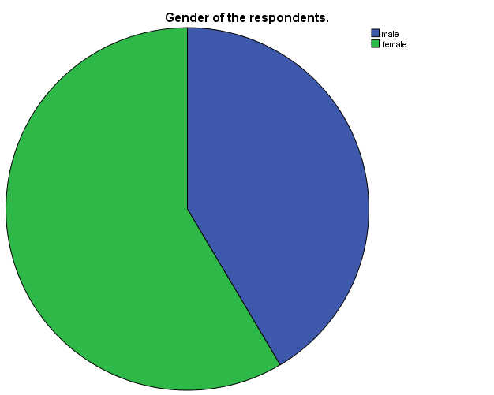

The findings showed that (41.5%) were male while (58.5%) were female.

### 4.3.2 Age of respondents.

This category shows the age of the respondents. The results were tabulated in the table below.

Table : Age of the respondents.

|  |  |  |  |  |  |
| --- | --- | --- | --- | --- | --- |
| **Age of the respondents.** | | | | | |
|  | | Frequency | Percent | Valid Percent | Cumulative Percent |
| Valid | 18-35 | 29 | 70.7 | 70.7 | 70.7 |
| 35 and above | 12 | 29.3 | 29.3 | 100.0 |
| Total | 41 | 100.0 | 100.0 |  |

The findings showed that most percentage of the respondents were aged 18 to 35 with 70.7% and the others above 35 years had 29.3%.

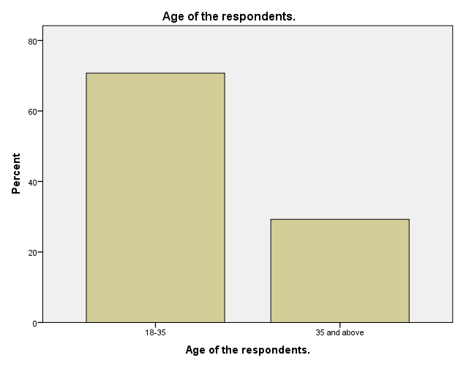

**4.3.3 Type of respondents.**

This category shows the type of the respondents. The results were tabulated in the table below.

Table : Type of the respondents.

|  |  |  |  |  |  |
| --- | --- | --- | --- | --- | --- |
| **Type of respondents.** | | | | | |
|  | | Frequency | Percent | Valid Percent | Cumulative Percent |
| Valid | tenants | 30 | 73.2 | 73.2 | 73.2 |
| landlords | 11 | 26.8 | 26.8 | 100.0 |
| Total | 41 | 100.0 | 100.0 |  |

The findings showed that most percentage of the respondents were tenants with 73% and the others landlords had 27%.

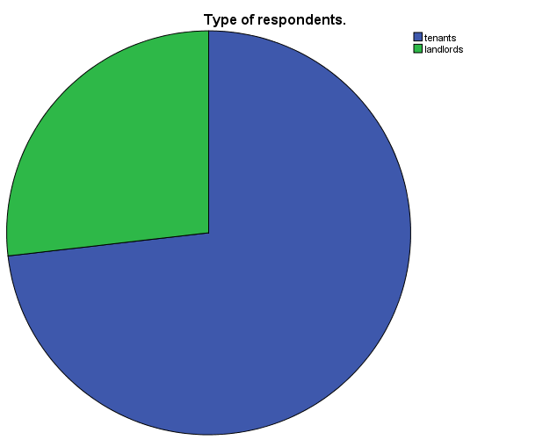

## 4.4 Response on software requirements to develop the proposed system

This question mainly targeted all the respondents who were asked to indicate or give a yes or no and not sure whether the software required to develop the proposed system may be available. The table below shows the outcome of the respondents

Table : Software requirements of the proposed system.

|  |  |  |  |  |  |
| --- | --- | --- | --- | --- | --- |
| **Are software requirements available?** | | | | | |
|  | | Frequency | Percent | Valid Percent | Cumulative Percent |
| Valid | Yes | 33 | 80.5 | 80.5 | 80.5 |
| No | 3 | 7.3 | 7.3 | 87.8 |
| Not sure | 5 | 12.2 | 12.2 | 100.0 |
| Total | 41 | 100.0 | 100.0 |  |

In above table, a large proportion of respondent 80.5% say that the software required to develop the proposed system may be available 7.4% of them say no while 12.1% are not sure. This indicates that it’s possible to develop the proposed system in Rongo Sub County.

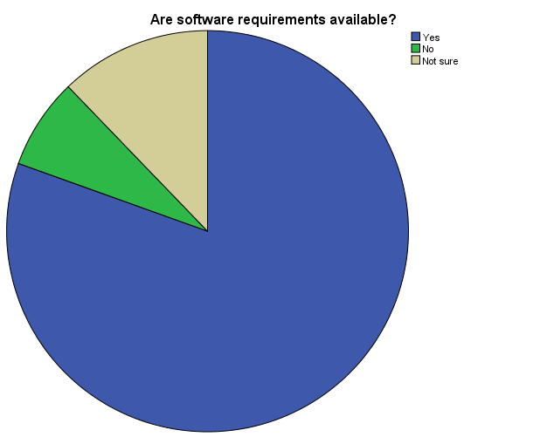

## 4.5 Response on how the payment information is followed.

This question targeted mainly the landlords and they were to suggest whether it is by manual means or digital means. The table below shows the outcome of the respondents

Table : Follow up in rent payment.

|  |  |  |  |  |  |
| --- | --- | --- | --- | --- | --- |
| **Follow up in rent payment.** | | | | | |
|  | | Frequency | Percent | Valid Percent | Cumulative Percent |
| Valid | Manual | 29 | 70.7 | 70.7 | 70.7 |
| Digital | 12 | 29.3 | 29.3 | 100.0 |
| Total | 41 | 100.0 | 100.0 |  |

In above table, a large proportion of respondent 70.7 % say that payment information is followed through the manual means while 29.3 % say through digital means .This indicates that there is need to develop the proposed system in order to make it easy for the landlords to follow up information.

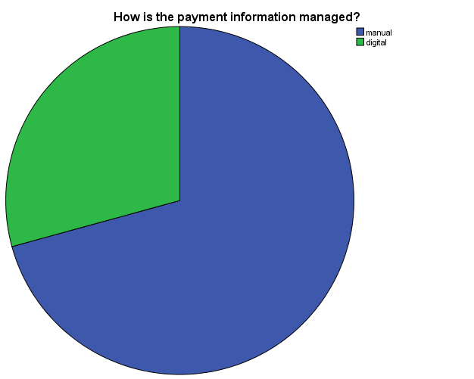

## 4.6 Response on whether the system will be convenient.

This question was asked to get information from the respondents on whether the system will be convenient to them and the table below gives the response.

Table : Convenience of rent payment follow up system.

|  |  |  |  |  |  |
| --- | --- | --- | --- | --- | --- |
| **Will it be convenient for rent payment follow up?** | | | | | |
|  | | Frequency | Percent | Valid Percent | Cumulative Percent |
| Valid | yes | 39 | 95.1 | 95.1 | 95.1 |
| no | 1 | 2.4 | 2.4 | 97.6 |
| not sure | 1 | 2.4 | 2.4 | 100.0 |
| Total | 41 | 100.0 | 100.0 |  |

In above table, a large proportion of respondent 94 % say that the system will be convenient 2% say no while 2 % say they are not sure .This indicates that the system will be convenient to most users.

Analysis.

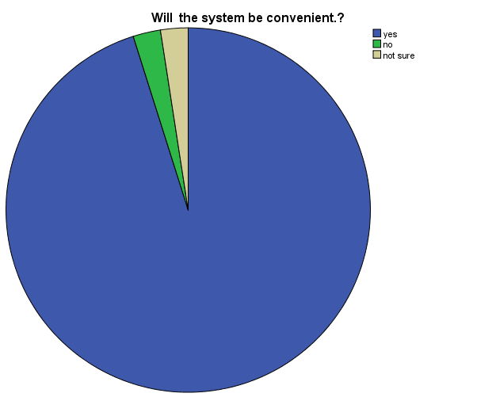

**4.7 Response on time will be saved in following up payment records.**

Table : Time savings in rent payment follow up.

|  |  |  |
| --- | --- | --- |
| Response | respondents | Percentage |
| Strongly Agree | 36 | 88% |
| Agree | 3 | 8% |
| Neutral | 1 | 2% |
| Disagree | 1 | 2% |
| Strongly Disagree | 0 | 0% |
| Total | 41 | 100% |

Analysis.

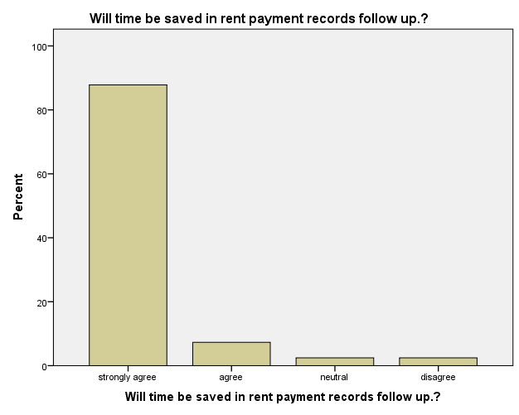

# CHAPTER 5

## 5.1 SYSTEM DESIGN

Before developing a system we have to design our system like how Use case of our

System. Data Flow Diagram (DFD) provides a view of how the system or business flows that able to increase the efficiency and effectiveness to achieve system objectives. For native user we have Use Case Diagram thus they could easily understand about our system. Entity Relationship Diagram (ERD) will tell us about our database.

### 5.1.1 UML Design:

The Unified Modeling Language is a general-purpose, modeling

Language in the field of software engineering used to provide a standard way to visualize the design of a system.

### 5.1.2 Use Case:

Use Case Diagrams are used to describe the functionality of a system in a horizontal way. That is, rather than merely representing the details of individual features of your system,

They can be used to show all of its available functionality.

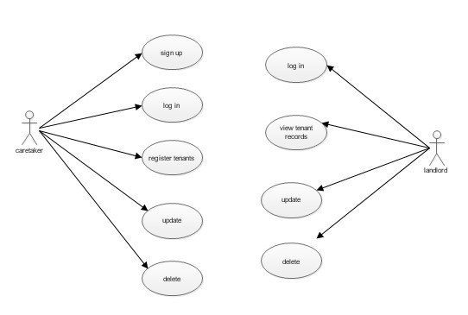

Figure : Use case diagram

**Application design and data flow diagrams (DFDs)**

Caretaker Registration

Caretaker Login

Register tenants

View the database

Update the database

Landlord authentication

View the tenant records

Update the record

Delete the database

Delete the record

Figure : Level 0 DFD

Caretaker

Admin

Authentication

**Firebase**

**Real-time Database**

Figure : Level 1 DFD

N

Launch APK

User caretaker?

Is landlord registered?

N

Y

Contact Admin

Login

Is Login Correct?

N

* View the records
* Update the records
* Delete the records

Y

Caretaker registered?

Create account

N

Login

Is Login Correct?

* Register tenants
* View the records
* Update the records
* Delete the records

Master DB

Logout

**Y**

**Y**

Y

Figure : System Flowchart

**ER diagram.**

This is the graphical representation of a system entities, their attributes and the relationships between them.

R.P.F.S

Tenant

Landlord

Admin

Caretaker

Figure : ER diagram.

## 5.2 IMPLEMENTATION:

Implementation is when the theoretical design is turned out into a working system. Thus it is considered to be the most critical stage in achieving a successful new system and in giving the user, confidence that the new system will work and be effective.

The implementation stage involves careful planning, investigation of the existing system and it’s constraints on implementation, designing of methods to achieve changeover and evaluation of changeover methods.

### 5.2.1 DEVELOPMENT ENVIRONMENT

The system platform used is android studio. The programming language used is java and xml. Java is widely used for application development.

### 5.2.2 IMPLEMENTATION ARCHITECTURE

Firebase

Realtime

Database

XML

Java

BackEnd

FrontEnd

Figure : implementation architecture.

## 5.3 SYSTEM TESTING

Testing is done to discover errors. It provides a way to check the functionality of components, sub-assemblies, assemblies or a finished product. It is the process of exercising software with the intent of ensuring that the software system meets its requirements and user expectations and does not fail in an unacceptable manner. There are various types of test. Each test type addresses a specific testing requirement.

### 5.3.1. Unit testing

Unit testing involves the design of test cases that validate that the internal program logic is functioning properly, and that program inputs produce valid outputs. All decision branches and internal code flow should be validated. It is the testing of individual software units of the application.

**Test strategy and approach**

Field testing will be performed manually and functional tests will be written in detail.

**Features to be tested**

* Verify that the entries are of the correct format
* All links should take the user to the correct page.

### 5.3.2 Integration testing

Integration tests are designed to test integrated software components to determine if they actually run as one program. Testing is event driven and is more concerned with the basic outcome of screens or fields. Itis the incremental integration testing of two or more integrated software components on a single platform to produce failures caused by interface defects.

**The task of the integration test is to check that components or software applications, e.g.** components in a software system or – one step up – software applications at the company level – interact without error.

**Test Results:**

All the test cases mentioned above passed successfully. No defects encountered.

**5.3.3 Acceptance Testing:**

User Acceptance Testing is a critical phase of any project and requires significant participation by the end user. It also ensures that the system meets the functional requirements.

**Test Results:**

All the test cases mentioned above passed successfully. No defects encountered.

## 5.4 System demos

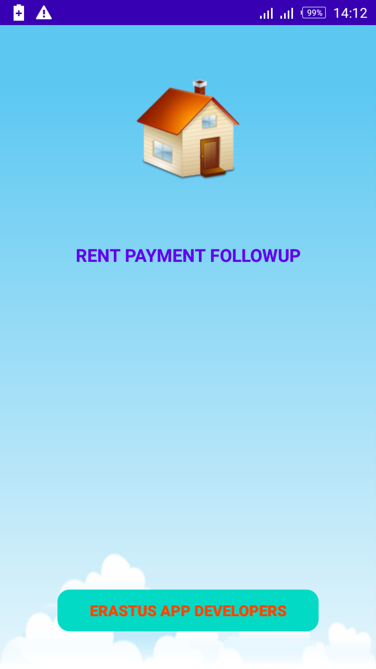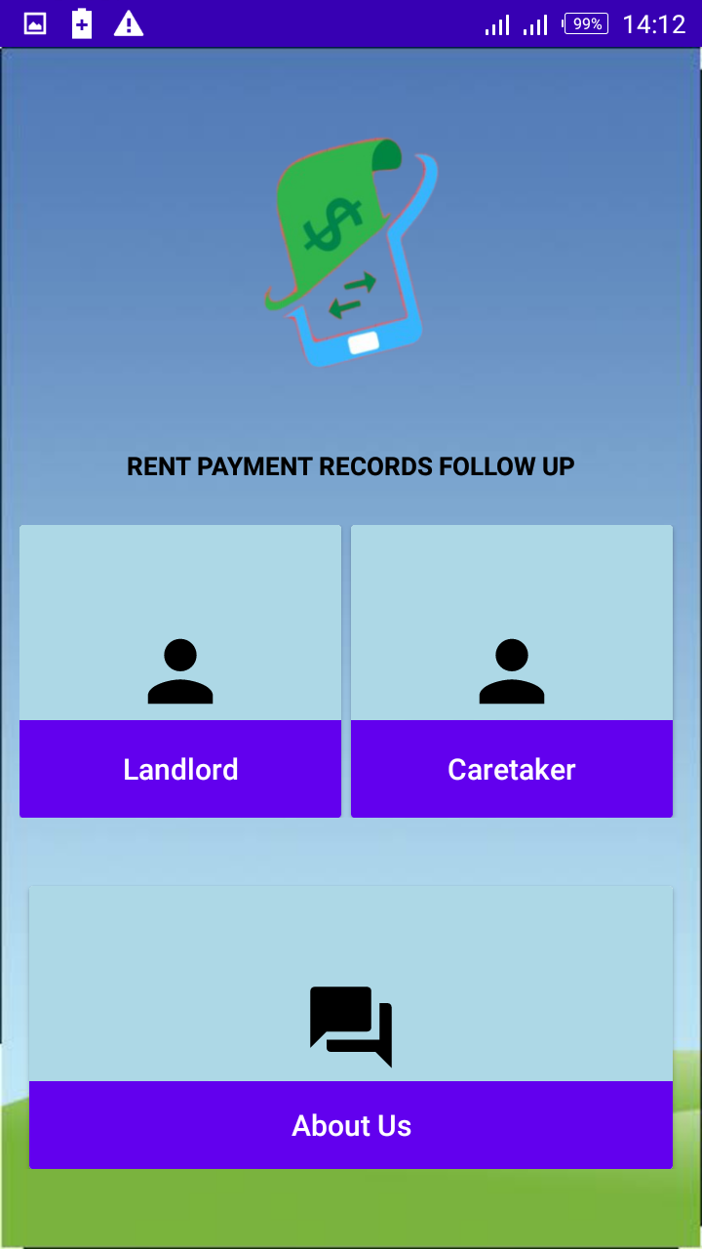

Figure : Landing page and the dashboard

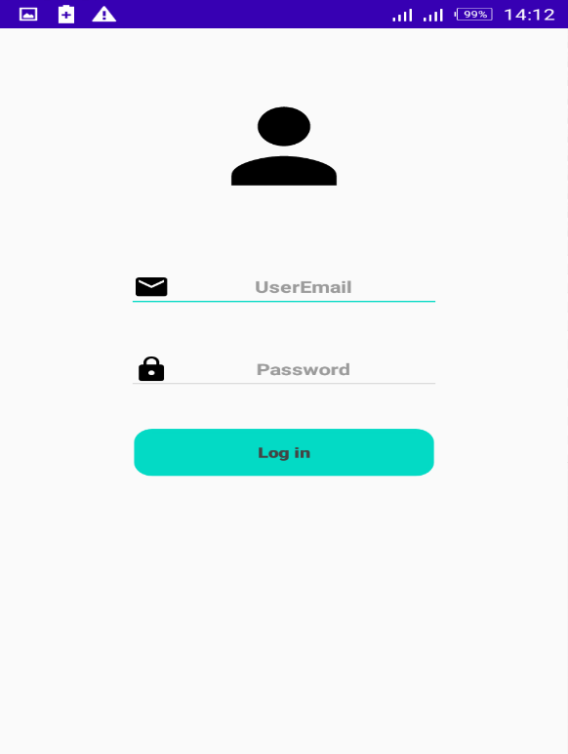 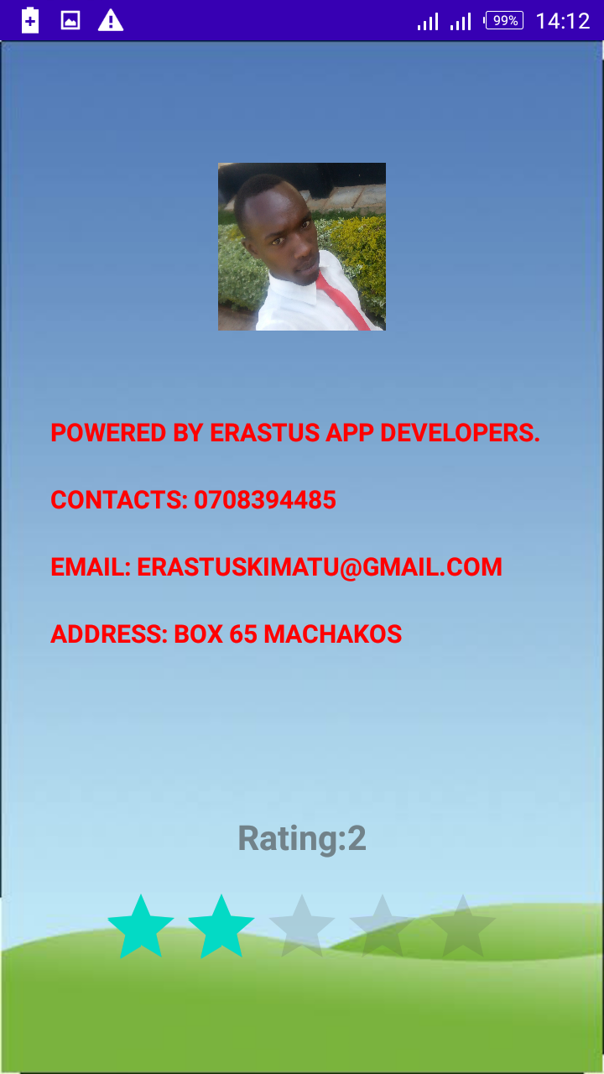

Figure : Landlord login page and about us page

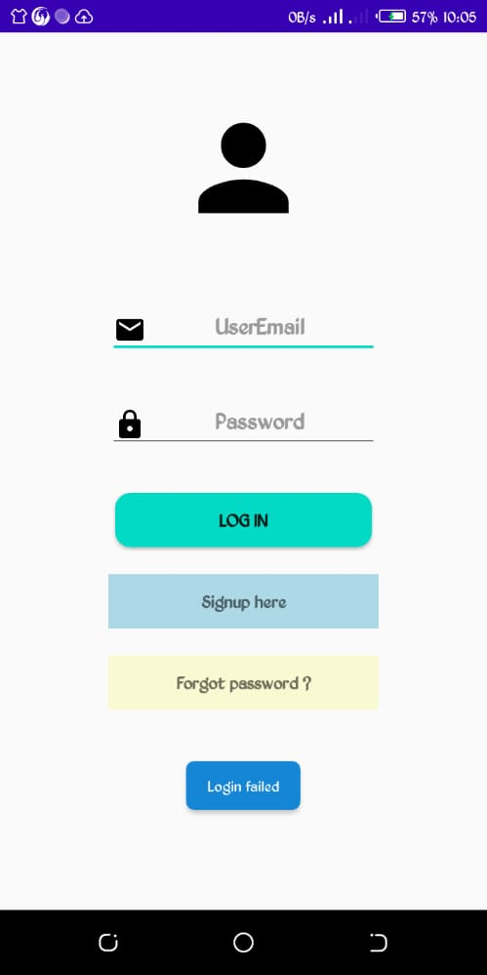 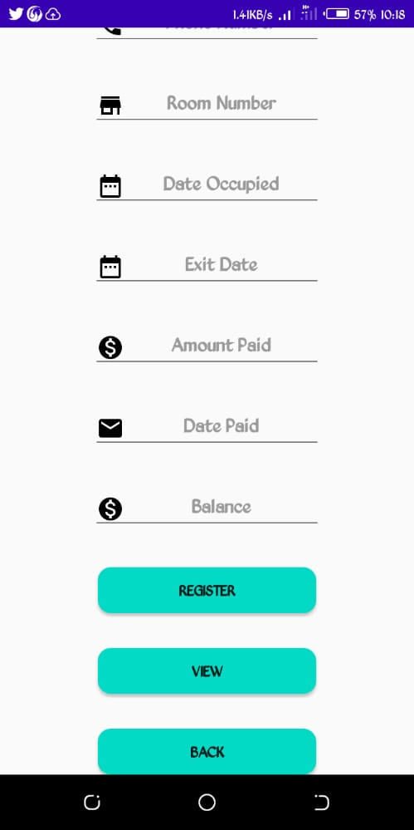 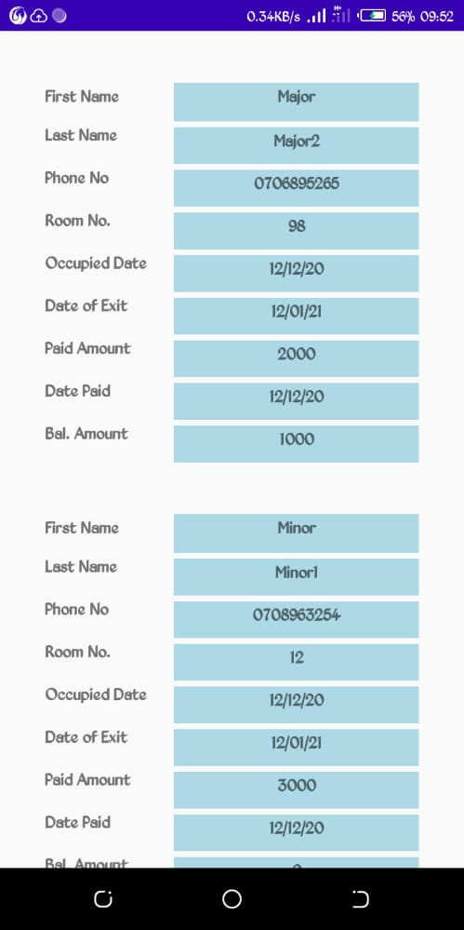

Figure : Caretaker login page, Registration page and view of the tenants in database

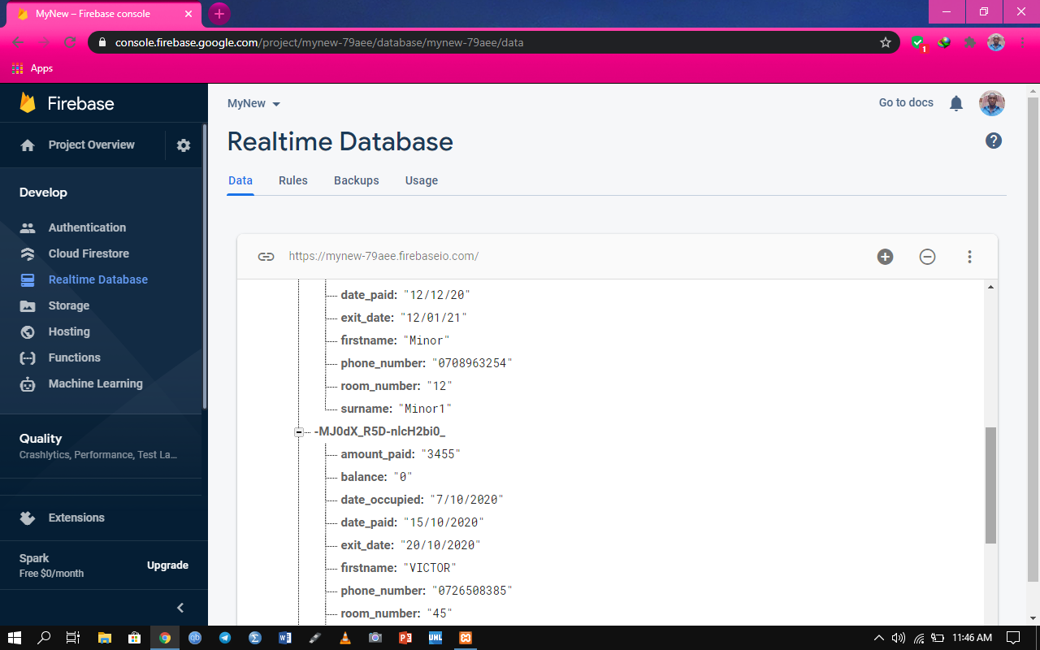

Figure : Database showing tenants.

## 5.5 USER MANUAL

The program may be maintained on the ground that the system requires an upgrade. When there is a new field to be added or a new form to be added in other to serve users well. Though it is compiled as standalone software the database can be tempered with but it’s advisable that the admin put a password on the file to secure the database from intrusion.

**THE FOLLOWING PRECAUTION SHOULD BE DONE**

Backup database frequently and use strong passwords.

## 5.6 SUMMARRY, RECOMMENDATION, CONCLUSION AND THE PROBLEMS ENCOUNTERED

### 5.6.1 SUMMARY

This project is a follow up design system for the tenants’ payments where one can register as a caretaker, register the tenant, update details and delete the record also. The admin who is the landlord can be able to login, view the records as entered by the caretaker. He or she can also update or delete the tenants’ records.

### 5.6.2 CONCLUSION

Most rental houses tend to concentrate much on keeping such records manually and also update them manually. I think this system will help them monitor and follow all the activities to help provide timely follow up for those not paying in time. Last but not least it is not the work that played the ways to success but ALMIGHTY GOD

### 5.6.3 RECOMMENDATION

In the development of this rent payment follow up design system, I will recommend that if there is going to be any modification to the system it should endeavor to improve on the limitations.

It is with utmost faith that I present this software to you hoping that it will solve your problems and encourage you to continue appreciating technology because it is meant to change and ease all our work that seems to be very difficult. I don’t mean that my project is the best or that I have used the best technology available it just a simple and a humble venture that is easy to understand. However, I would encourage anyone who has the ability to advance it using advanced technologies so as to increase its capabilities.

### 5.6.4 PROBLEM ENCOUNTERED

The following are some of the problems or challenges encountered.

* Insufficient time on research to get more information from users and add functionality to more system.
* Insufficient funds to get advanced features and hardware for developing features and computer failure issues

**RONGO UNIVERSITY QUESTIONNAIRE TO BE ADMINISTERED TO RENTAL HOUSES MANAGERS/OWNERS.**

Dear respondent; I am Erastus Mula Kimatu student at Rongo University, school of Information, Communication And Media Studies undertaking a research project on Rent Records Follow Up . Your support towards this research will be appreciated and be treated with utmost confidentiality and for only academic purposes.

**SECTION A: Background information of the respondents.**

Fill in the questions below by ticking where appropriate  
 1. Kindly indicate your gender Male [ ] Female [ ]

2. Which is your age bracket? 18-35years [ ] 36 and above [ ]

3. How many rental houses do you have? Indicate Number…………………..

4. Do you have challenges in following up tenants’ payment records? Yes [ ] No [ ]

5. If yes, kindly indicate some of the challenges you face i)………………………………………………………………………………………. ii)………………………………………………………………………………………

iii)………………………………………………………………………………………

iv)………………………………………………………………………………………

6. Would you like to have a system that can assist you in following up payment records?

Yes [ ] No [ ]

**SECTION B: Payment Records Follow Up System**

Please indicate your level of agreement with the statements below.

The main objective of developing rental houses is to make money through rent paid by tenants.

Strongly Agree [ ] Agree [ ] Strongly Disagree [ ] Disagree [ ] Not Sure [ ]

Rental payments need to be followed up by a system follow up which will assist to achieve the objective of owning rental houses.

Strongly Agree [ ] Agree [ ] Strongly Disagree [ ] Disagree [ ] Not Sure [ ]

The follow up system should be easy to understand, flexible and quickly accessible.

Strongly Agree [ ] Agree [ ] Strongly Disagree [ ] Disagree [ ] Not Sure [ ]

**RONGO UNIVERSITY QUESTIONNAIRE TO BE ADMINISTERED TO RENTAL TENANTS.**

Dear respondent; I am Erastus Mula Kimatu student at Rongo University, school of Information, Communication And Media Studies undertaking a research project on Rent Records Follow Up . Your support towards this research will be appreciated and be treated with utmost confidentiality and for only academic purposes.

**SECTION A: Background information of the respondents.**

Fill in the questions below by ticking where appropriate  
 1. Kindly indicate your gender Male [ ] Female [ ]

2. Which is your age bracket? 18-35years [ ] 36 and above [ ]

3. Do you have challenges in following up your rent payment records? Yes [ ] No [ ]

4. If yes, kindly indicate some of the challenges you face i)……………………………………………………………………………………… ii)………………………………………………………………………………………

iii)………………………………………………………………………………………

iv)………………………………………………………………………………………

5. Kindly indicate the greatest challenge?

i)…………………………………………………………………………………………..

6. Would you like to have a system that can assist you in following up your payment records?

Yes [ ] No [ ]

# APPENDIX I. MAP OF THE AREA

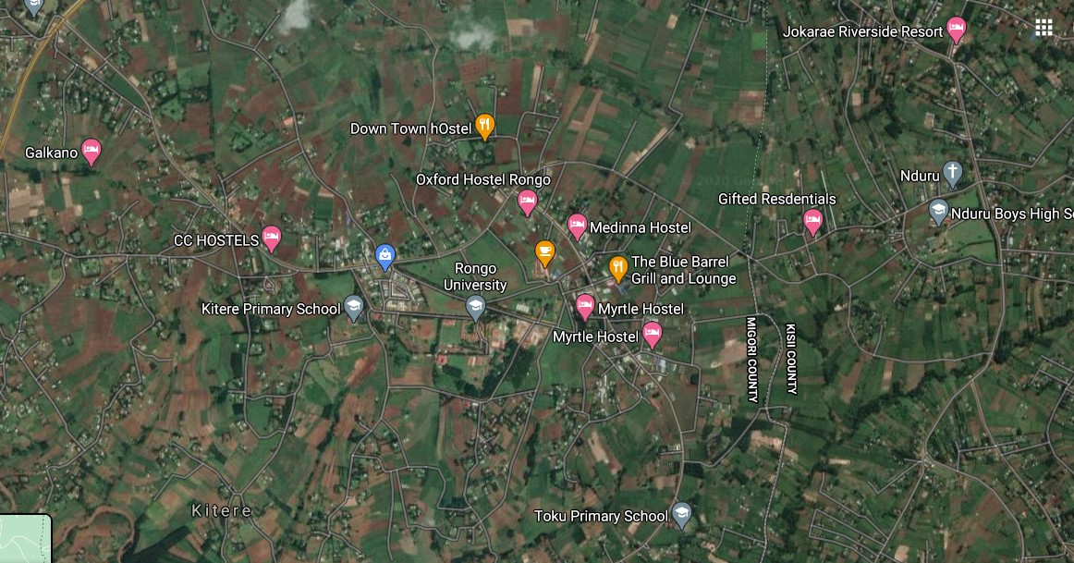

# APPENDIX II. Budget.

|  |  |
| --- | --- |
| **Resource Name/work.** | **Cost.** |
| **Notebook** | 50 |
| **Pen** | 10 |
| **Internet** | 100 |
| **Printing** | 300 |
| **Transport** | 500 |
| **Modem** | 2,000 |
| **Total** | 2,950 |

Table : Budget.

# APPENDIX III. Tools and research instruments.

|  |  |
| --- | --- |
| **Tool** | **Description** |
| **Questionnaires** | I will issue questionnaires to the respondents. |
| **Interviews** | I will personally interrogate the target respondents. |
| **Observations** | I will observe the daily activities of the study population |

Table : Tools and instruments.

# References

ACKOFF, R. L. (1953). *The Design of Social Research.* Chicago: University of Chicago Press.

Bell, J. (1999). *Doing your research project.* Buckingham: OUP.

Cooper, H. M. (1998). *The Structure of Knowledge Synthesis.* London: 1: 104-126.

duhaime. (2015).

Ghauri and Gronhaug. (2005). *Research Methods In Business Studies.* Harlow: FT/Prentice Hall.

Hounsome, C. (2001). *The records management challenges of amalgamation.*

Nations, U. (1948). *The Human Rights.*

O'Brien, J. (2011). *Management Information Systems.* Newyork: McGraw-Hill Higher Education.

Orlikowski. (1992). *The Duality of Technology.* New York.: New York University.

PM., H. (1994). *Qualitative Research for Public Health Programmes. .* Geneva: WHO/MNH/PSF/94.3.

*Rental Property.* (2015). Canberra: Australian Taxation Office.

Robert E. Stake. (1995 ). *The Art of Case Study Research.* California : Sage Publications.

Thomas. (2011). *Typology of a case study.* Birmingham: Birmingham University.

# APPENDIX IV. GLOSSARY

|  |  |
| --- | --- |
| 1. MB | Megabytes |
| 2. GB | Gigabytes |
| 3. SQL | Structural Query language |
| 4. Admin | Administrator |
| 5. RAM | Random Memory |
| 6.DFD | Data flow diagram |
| 7.RPFS | Rent Payment Follow up System |
| 8.ERD | Entity Relationship Diagram |